Eproject

E-Project for <Semester 1>

---

<Bid Spirit>

---

|  |  |
| --- | --- |
| **Authors** | **Aptech – C2310L - Group : 4** |
| 1. <THINH XUAN TU> - < Studen1527948> [(Leader)] 2. <KHOA MINH TRAN> - <Student1527786> 3. <THIEN NGUYEN THANH> - <Student1545352> 4. <KHANH NGUYEN> - <Student1521283> |
| **Centre Name** | Aprotrain Aptech |
| **Date** | 15 OCTOBER, 2024 |
| Course | ACCP |
| Curriculum Code | OV-7091-ADSE |
| **Semester** | Semester 1 |
| **Instructor** | HUNG DANG NGUYEN THE |

**Ho Chi Minh City, 17/09/2024**

**TABLE OF CONTENTS**

Clearly organized list of document sections and subsections

1. **Introduce eProject – Project name:** 3
2. Problem definition of project 3
3. List of Inputs to the Website 3
4. List of Outputs Expected from the Website 3
5. Overview of Processes Involved in the Website 3
6. Hardware and Software Required for Implementing the Project 4
7. Flow chart 4
8. Table assigning tasks to members (Leader) 5
9. **Instruction to run the project** 6
   1. Import database and tables into SQL Server 6
   2. Import Project into Visual Studio 7
   3. Run Web Application (Web Admin): 9
10. *Login 9*
11. *Manage Information of Claims/ Orders/ Customers 10*
    1. Run Web Application (Web User): 14
12. *Home Page 15*
13. *Login 17*
14. *Forgot Password 18*
15. *Register 19*
16. *Profile/Personal Order/ Change Password/ Logout 19*
17. *Insurance Plan Page 21*
18. *About Us Page 29*
19. *Contact Us Page 30*
    1. Database 29
20. *ER Diagram 29*
21. *Detail of Tables 30*
    1. Contributions 32

**INTRODUCE EPROJECT – PROJECT NAME**

* + - 1. **Problem definition of project:** (Introduce project)

**BidSpirit** is the world's leading online platform for fine art, antiques and collectibles. We offer a modern, efficient alternative to manual auctions, enabling users to easily participate, search for, and acquire their favorite items. With our revolutionized technique, the entire auction process can now be carried out at your fingertips, ensuring a seamless and convenient experience for all participants while maximizing profits.

* + - 1. **List of Inputs to the Website:**
* Admin:
* Login
* Create/Read/Update/Delete(CRUD) Auction/Category/Item/Users of User.
* Track user bid history
* User:
* Register/Login/Change Password.
* Bid
* Pay
* Track past, present and upcoming auctions
  + - 1. **List of Outputs Expected from the Website**
* Admin:

**1. User Dashboard**

Bid History: Users can view all bids they have placed.

Auction Participation: List of auctions where the user has bid.

Payment and Transaction Records: Including buyer’s premium calculations.

**2. Admin Panel Outputs**

Auction Management: Create, edit, and delete auctions with attributes like item, category, start date, end date, and start price.

Reports: Summary of auction results and bidder activity.

User Management: Overview of user activity and their bids.

* User:

**1. Auction Listings Page**

Active Auctions: List of ongoing auctions, including:

Auction Name

Category (e.g., Art, Coins, Antiques)

Start Date and End Date

Current Bid Amount (if applicable)

Status Indicator: "Upcoming," "Ongoing," or "Ended"

Countdown Timer for each auction to show time left until the auction ends.

**2. Auction Details Page**

Category: Type of auction (Art, Collectibles, etc.)

Item Details:

Name and Description

Images or Gallery of the item

Start Price

Current Bid Amount

Number of Bids Placed (bid_count)

Bid Form:

Dropdown for selecting bid amount.

Notification if the selected amount meets the reserve price.

Bid Increment Rules applied according to the price range.

**3. Bidding Process**

Validation: Ensure the bid amount meets or exceeds the current increment.

Reserve Price Check: Notification if the bid does not meet the reserve.

Auto Bidding System:

Platform bids on the user’s behalf up to the maximum bid.

Users notified if they are outbid by competitors.

Bid Extension: Auctions extend by 5 minutes if bids are placed within the last 5 minutes.

**4. Buyer's Premium Calculation**

Premium Breakdown:

25% for items under $500,000

20% for items between $500,001 and $1,000,000

15% for items over $1,000,001

Total Price Display: Winning bid + Buyer’s premium.

**5. Auction Status and Comments**

Comments Section:

Enabled only for ongoing auctions.

View-only comments available after the auction ends.

Status Changes:

"Upcoming" if auction is scheduled.

"Ongoing" during the auction time window.

"Ended" once the auction ends, with the end price and winner details.

**6. Winning Bid and End Price**

End Price:

If no bids, the end price defaults to the start price.

If bids were placed, the end price is the highest bid amount.

Winning Bidder: Display the user ID or name of the highest bidder after the auction concludes.

* + - 1. **Overview of Processes Involved in the Website**

**1. User Registration & Login**

* Users create accounts and log in to participate in auctions.

**2. Auction Creation & Management (Admin)**

* Admin sets up auctions with items, categories, start/end dates, and reserve prices.

**3. Auction Listing & Status Updates**

* Auctions are displayed with "Upcoming," "Ongoing," or "Ended" status.
* Countdown timers track auction durations.

**4. Bidding Process**

* Users place bids, following bid increments and reserve prices.
* Auto-bidding up to the maximum bid if multiple bidders compete.
* Auctions extend by 5 minutes if last-minute bids occur.

**5. Payment & Buyer’s Premium**

* Winning bidders pay the final price + buyer’s premium (15-25% based on value).
* Premium is charged to the buyer’s card at auction end.

**6. Auction Conclusion & Results**

* End Price set to the highest bid or default to the starting price if no bids.
* Winner and final price displayed.

**7. User Dashboard & Bid History**

* Users track their bid history, auction activity, and payments.

**8. Admin Reporting & Management**

* Admin reviews auction results and manages users and payments.
  + - 1. **Hardware and Software Required for Implementing the Project**
* Hardware:

**Server Infrastructure:**

-Cloud Server (e.g., AWS, Azure, or DigitalOcean)

- Minimum: 4-core CPU, 8 GB RAM, 100 GB SSD

- Recommended: Load balancer for scalability

**Database Server:**

- MySQL/PostgreSQL server

- Local Development Machine (for developers):

- 8 GB RAM, i5/i7 processor, 256 GB SSD

- Windows/macOS/Linux operating system

**Network Devices:**

- High-speed internet

- Firewall for security Software:

* SoftWare:

**Frontend Development:**

- HTML, CSS, JavaScript

- Bootstrap for UI styling

**Backend Development**:

- PHP (Laravel Framework)

- Composer (PHP dependency manager)

**Database:**

- MySQL for managing auction data

**Version Control:**

- Git/GitHub for code management and collaboration

**Development Environment**:

- Visual Studio Code

**Server and Hosting:**

- XAMPP

**Payment Gateway Integration:**

- VN PAY

* + - 1. **Flow chart of User**
* Admin:

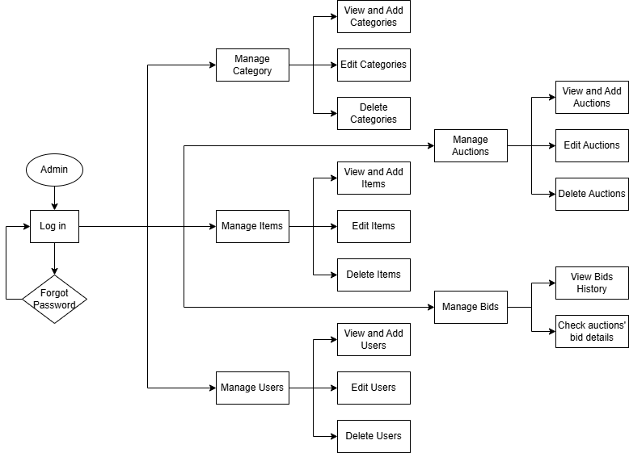

* User:

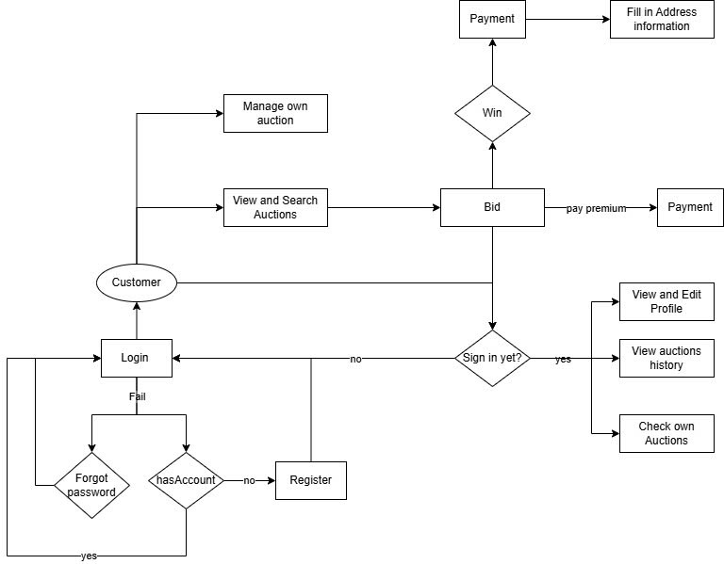

* 1. **Table assigning tasks to members (for Leader)**

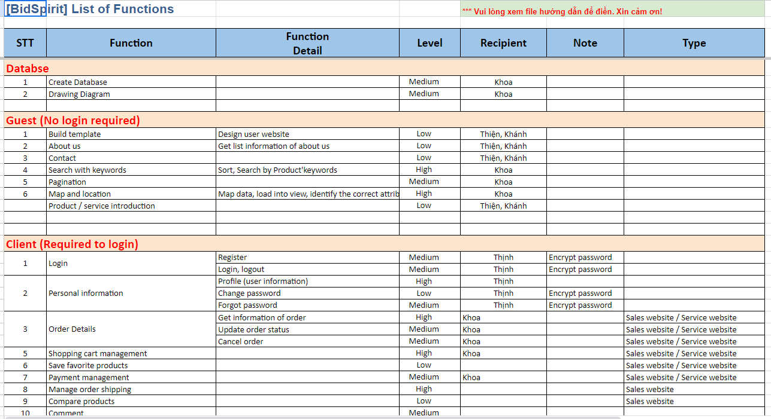

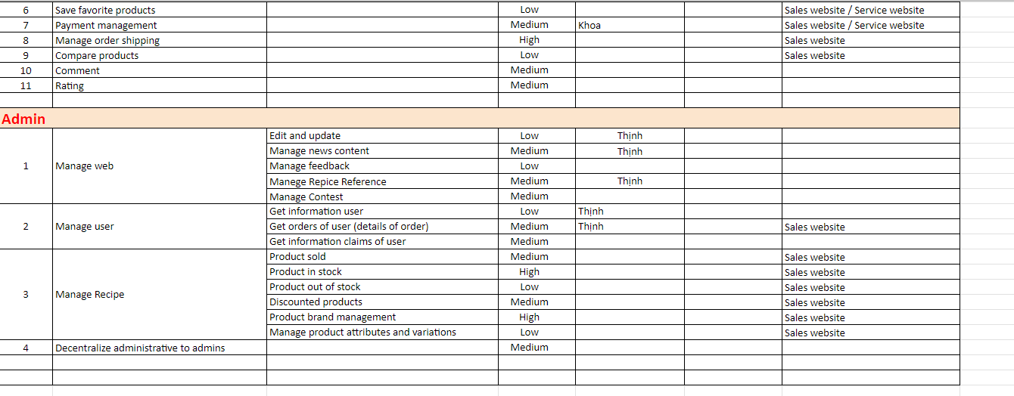

**INSTRUCTION TO RUN THE PROJECT**

1. **Import database and tables into SQL Server**

You open auction_project.sql file that We sent with MySQL in DBeaver. It looks like this:

Type **create** **database** auction_project; and highlight the following line: ( or you can go to project, choose git bash and migration)

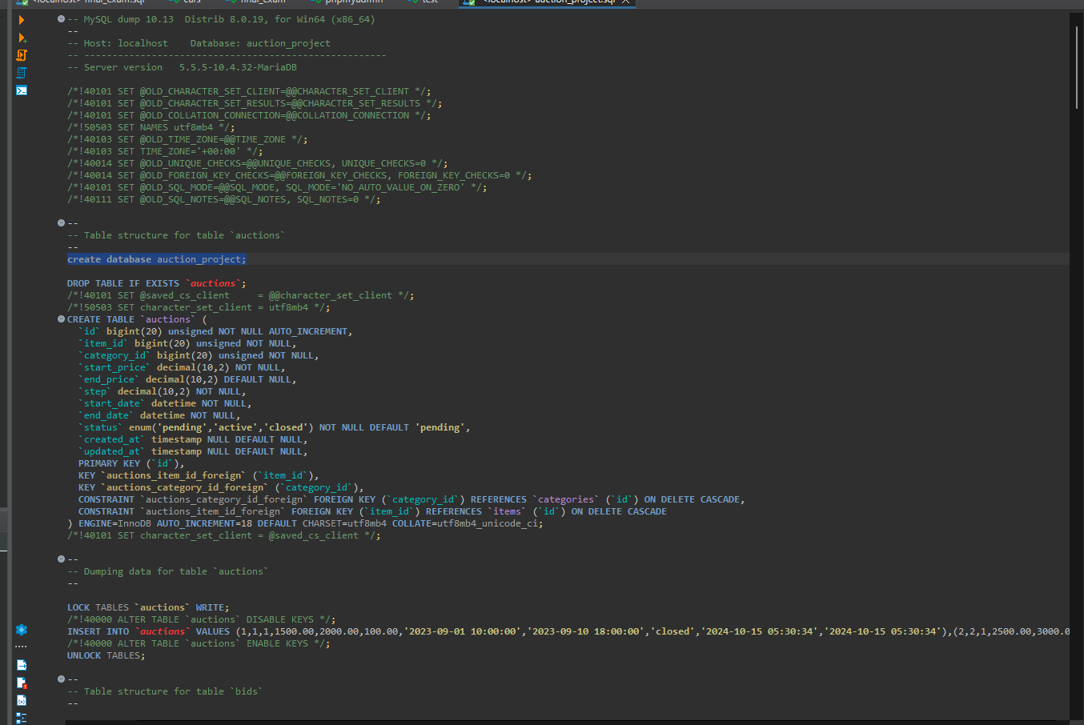

* run and we have this result 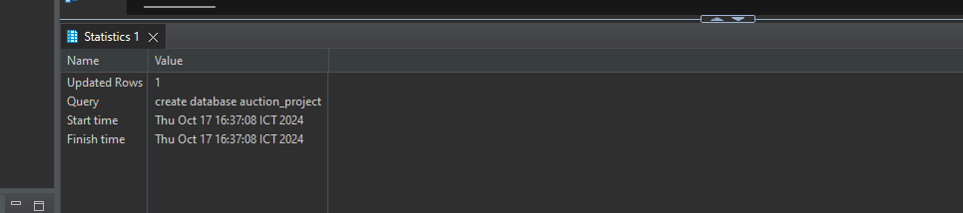

Select database

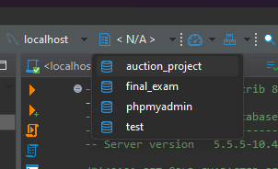

Then delete this line and highlight all line

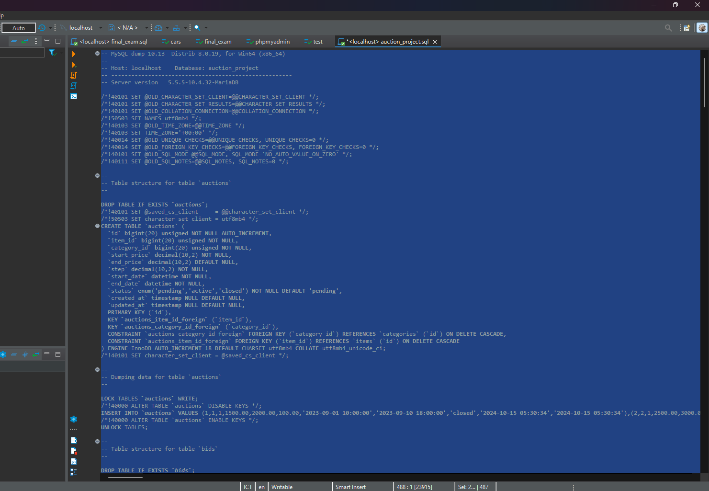

**Click:** 

Here is a result 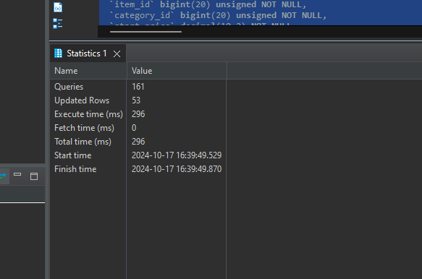

1. **Import Project into Visual Studio**

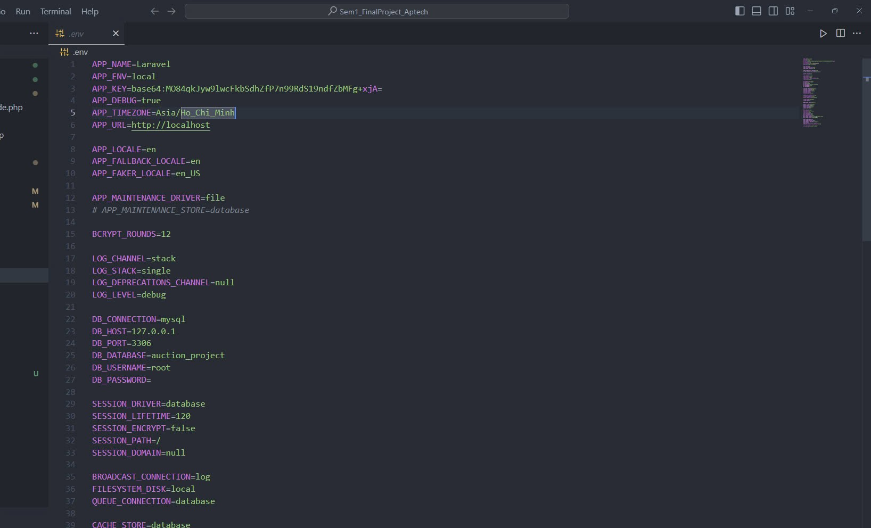

This is the configuration file.

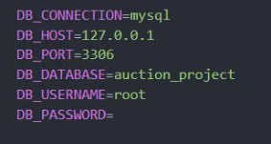

Enter database name, username and password as your mySQL account

1. **Run Web Application (Web Admin):**
2. Login

In database, I already insert admin account: [admin@gmail.com](mailto:admin@gmail.com) and Password: admin@123

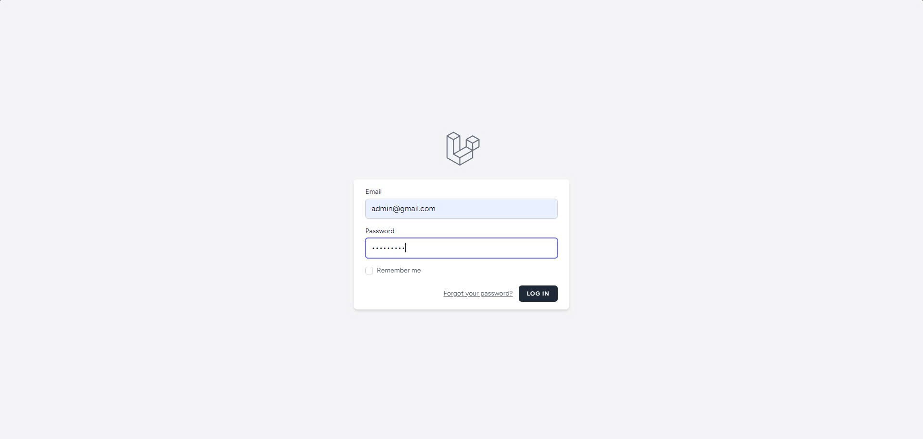

Here is admin homepage

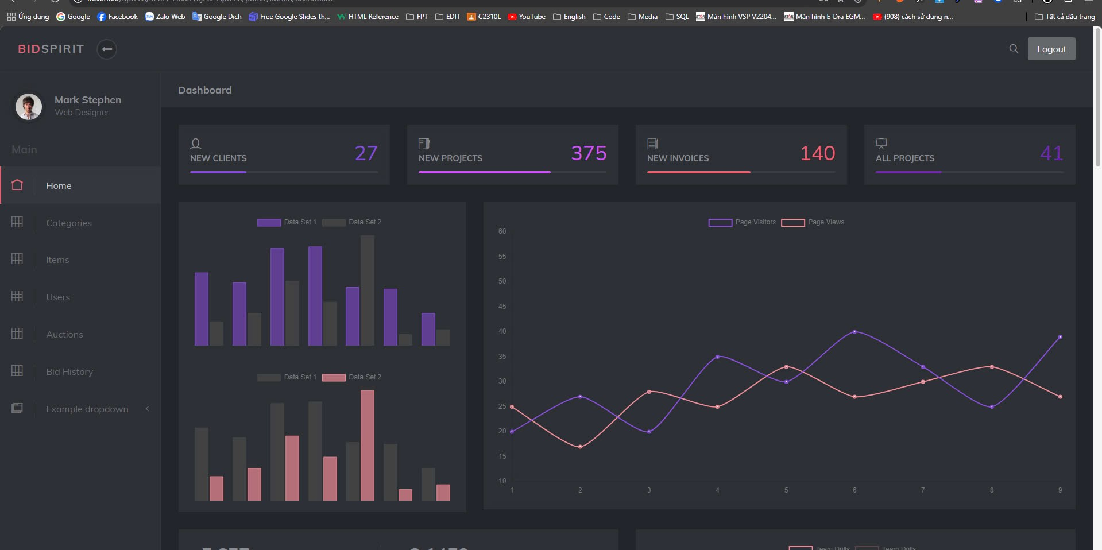

To go back Homepage of Bid Spirit, delete this in URL

The additional URL line is only accessible to admins when added to the URL.

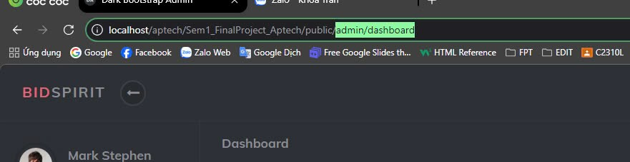

1. Manage Information of Claims/Customers/ Orders

**Manage Category**

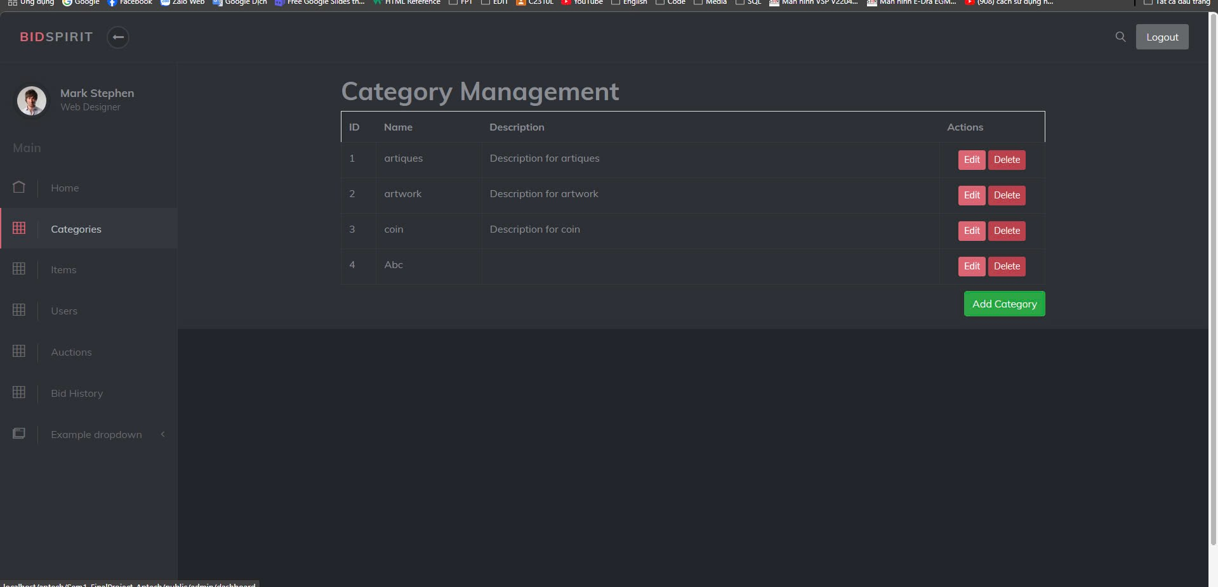

**Manage Item**

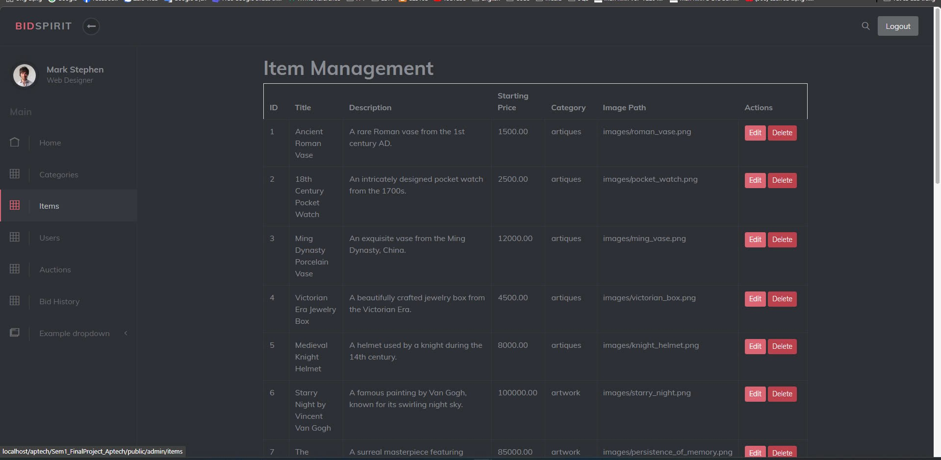

**Manage User**

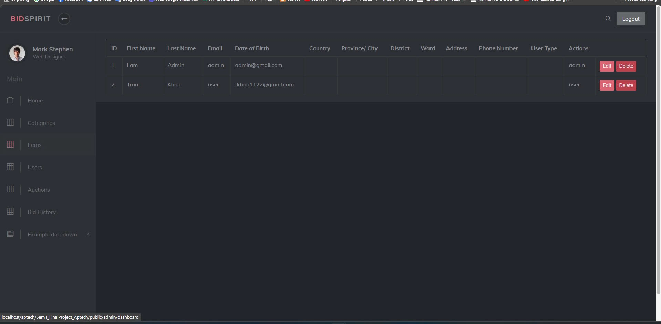

**Manage Auction**

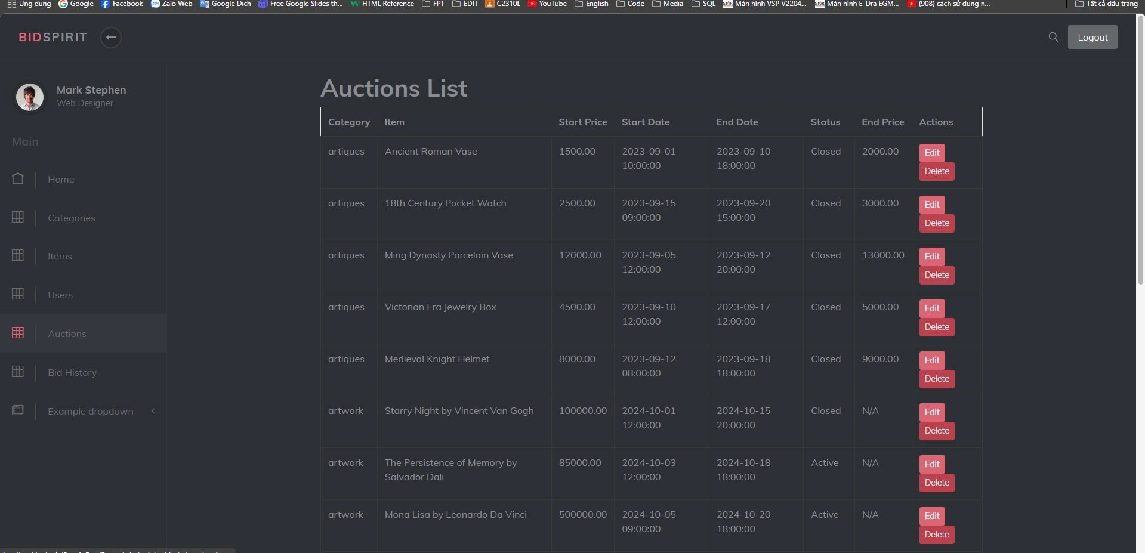

**Manage Bid History**

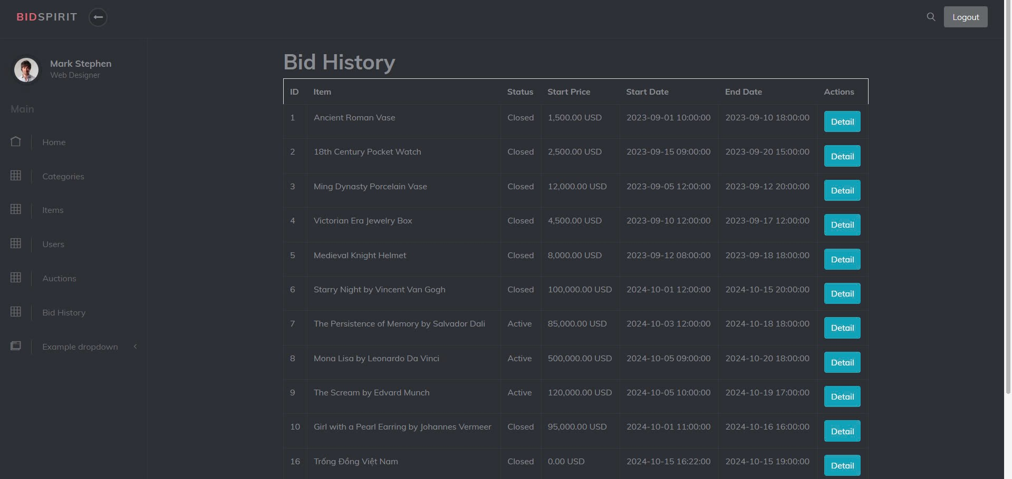

**4. Run Web Application (Web User): (example below)**

**a. Home Page:**

**First, our website has 3 default sections: header, body, footer. The header and footer  are default sections.**

**Header includes: website logo, website name, phone number, website menu and  social links.**

**Body includes: greeting, website images**



**Introduction about the website**

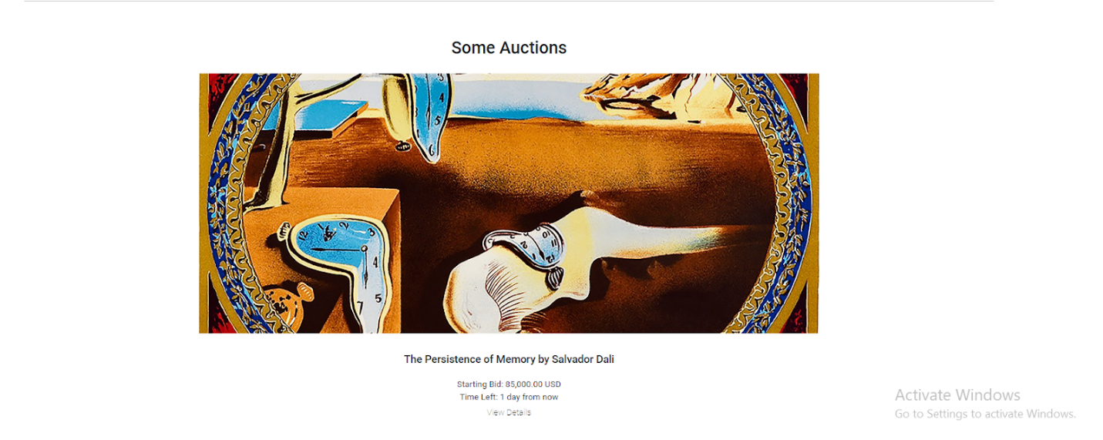

**Introduce about services that the website provides**

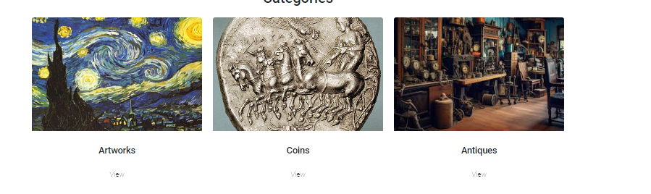

**Our target**

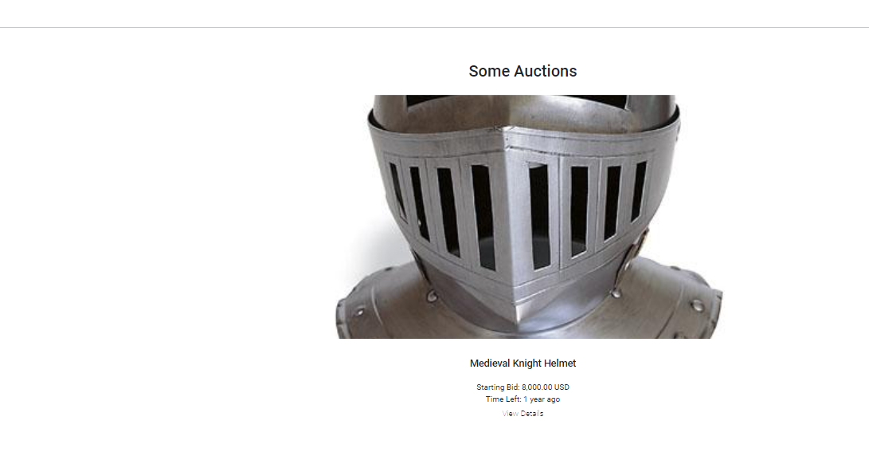

**Footer includes:**

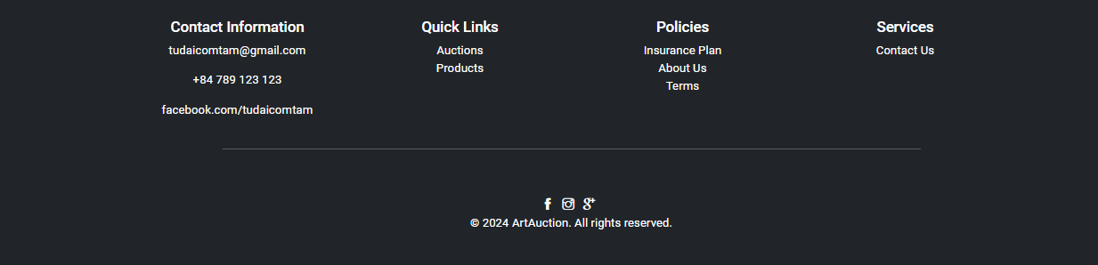

**b. Login**

**Look at the menu and click on ‘Login’ in website menu, fill your right email and  password then click Login button, you can sign in your account.**

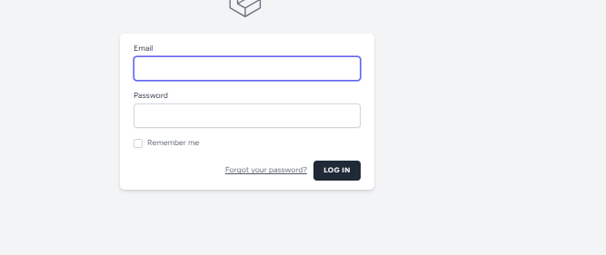**If you forgot your password, click ‘I forgot my password’ to recover your password.**

**If you don't have any account before, click ‘Register a new membership’ to register a  new account.**

**If you want to back to the Home page, click ‘Back to Home’.**

**If you forgot your password, click ‘I forgot my password’.**

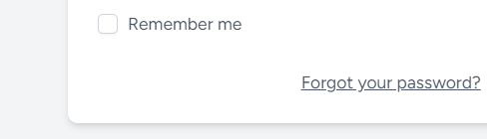

**c. Forgot Password**

**Fill your right mail and click Request new password button to confirm. 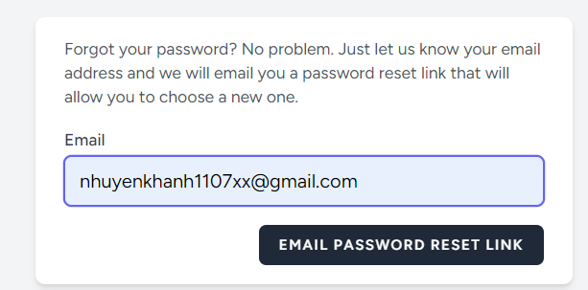Then, change a new password**

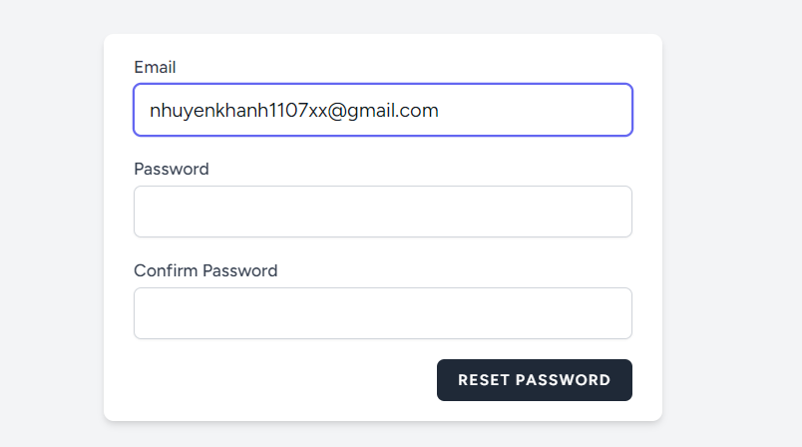**d. Register**

**Look at the menu and click on ‘Register’ in website menu, fill your right  information, then click Register button, you can register a new account.**

**If you want to go back to the Home page, click ‘Back to Home’.**



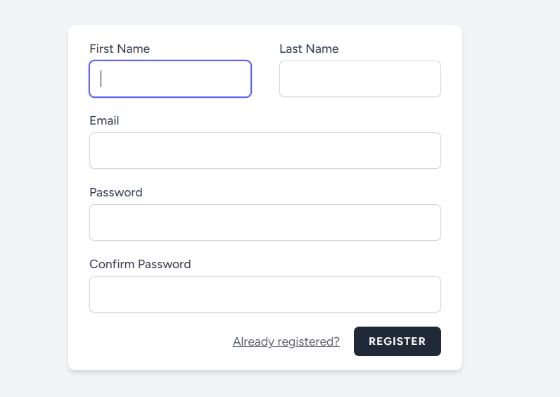

**User can see their information here: Profile.**



**Logout: when you want to leave your account**



Homepage will show some feature, some auction and kind of category of autions

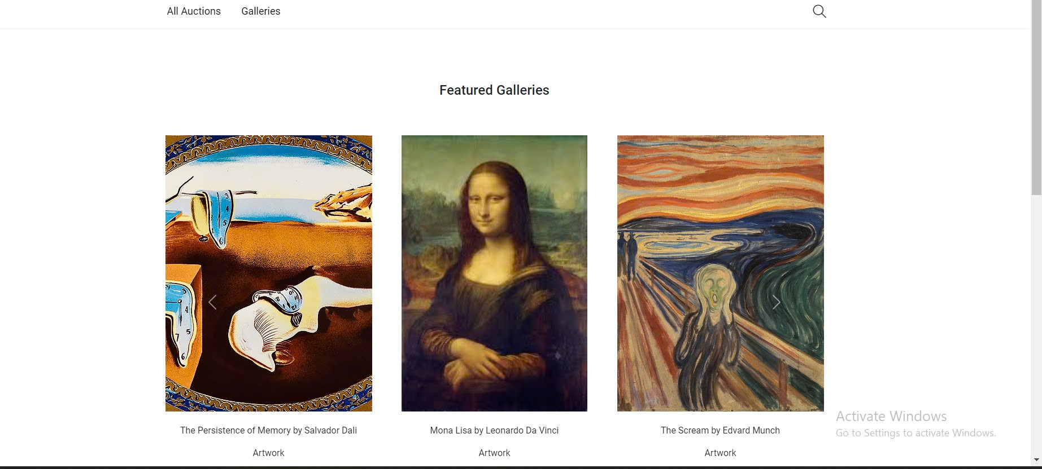

1. **Categoriespage**

This page will show all auction

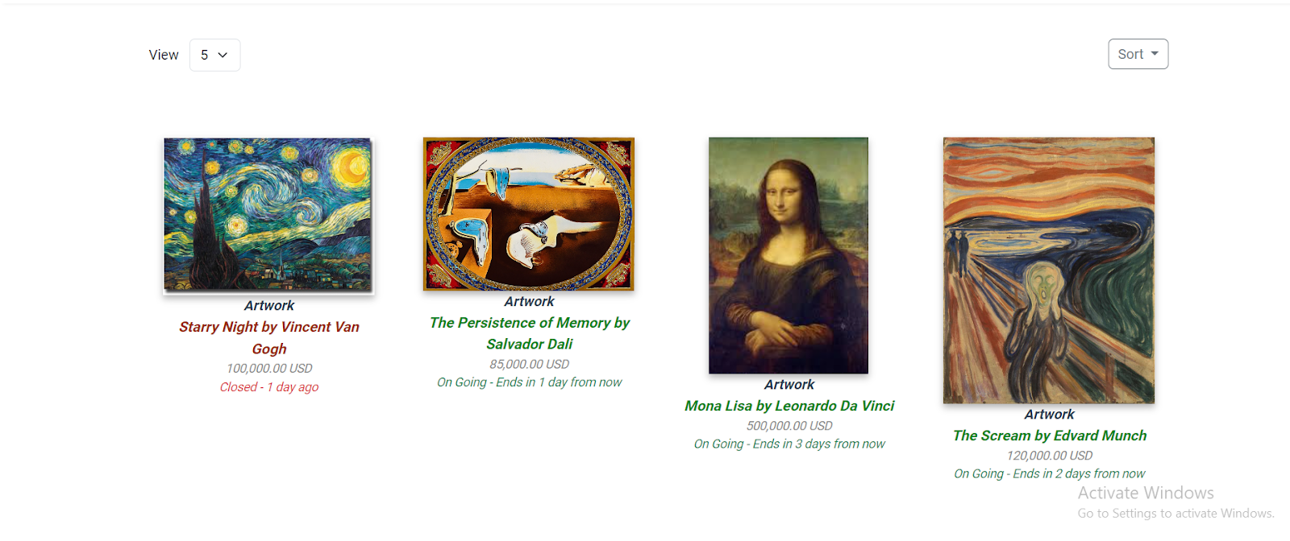**Click on the items you want to bid on**

1. **Detail**

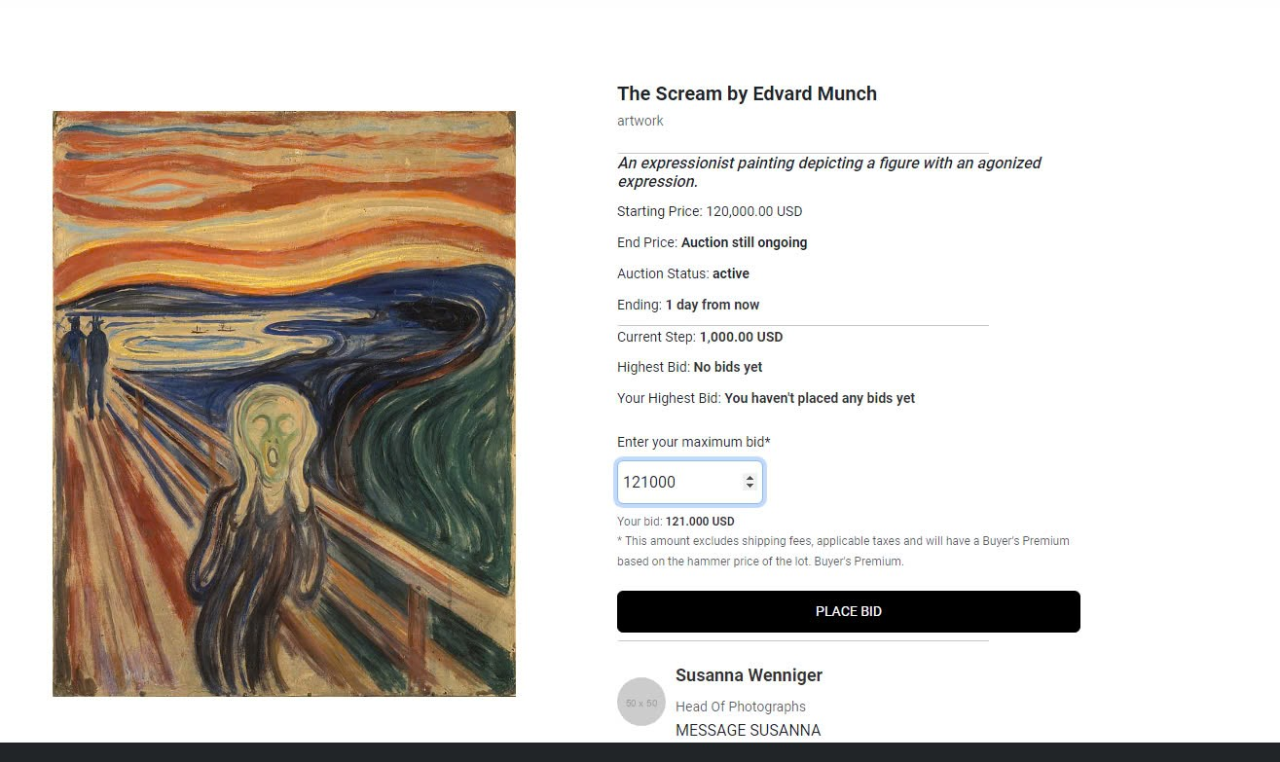

**Enter a higher price + step to bid**

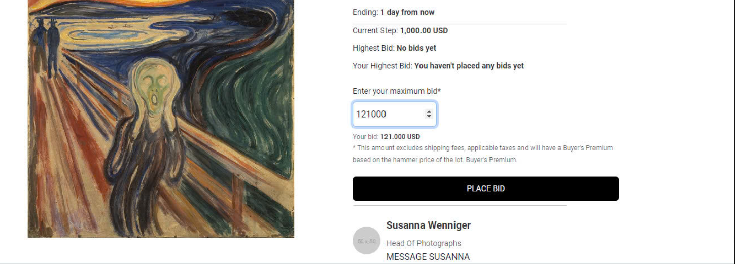

**Calculate and deposit by % of product**

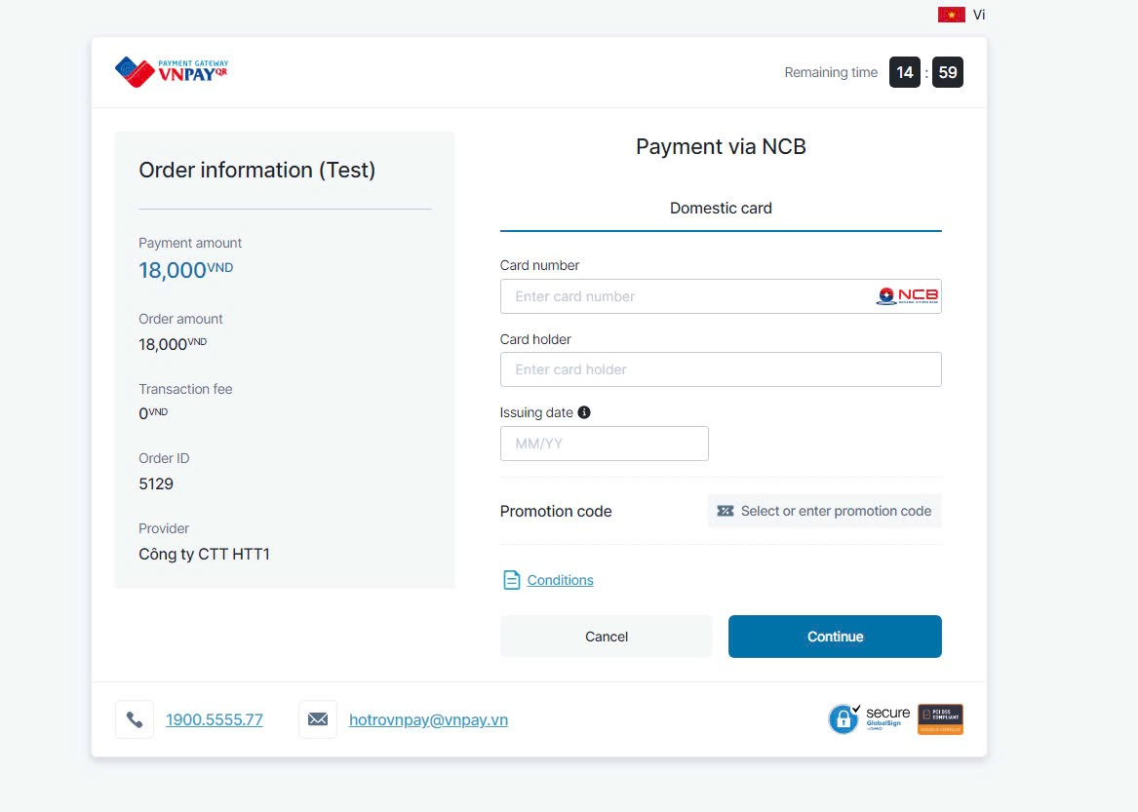

**25% for items under $500,000**

**20% for items between $500,001 and $1,000,000**

**15% for items over $1,000,001**

**Enter information**

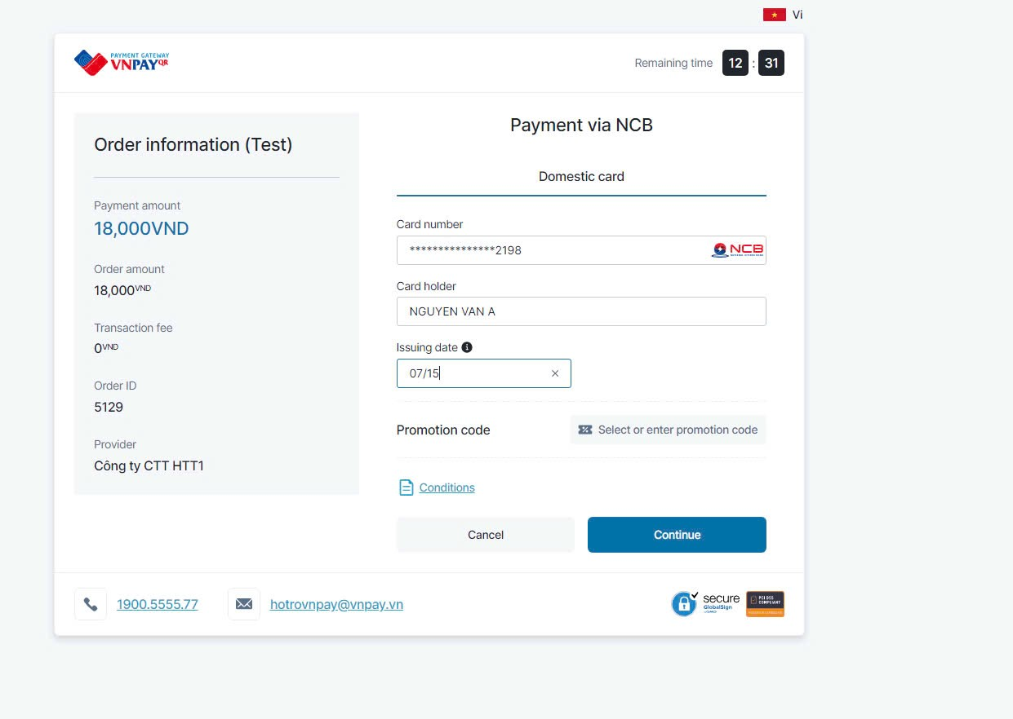

**Because this is a test case of VN PAY so we need to use test account sent by VN PAY in a gmail** 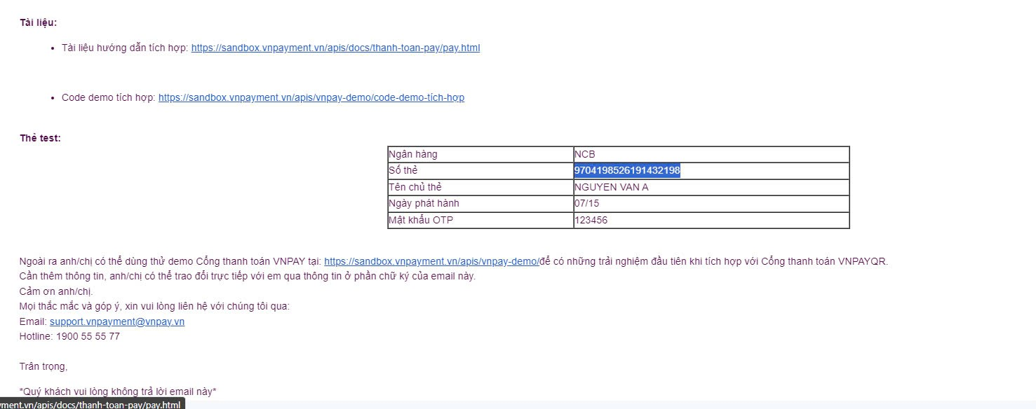

Type OTP

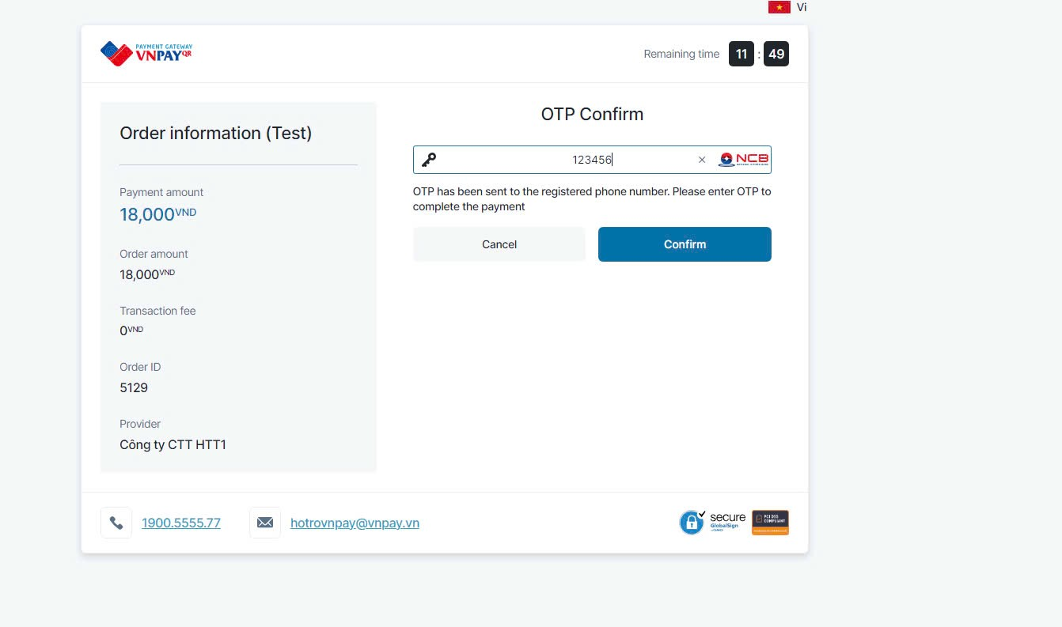

**Then it will return detailspage**

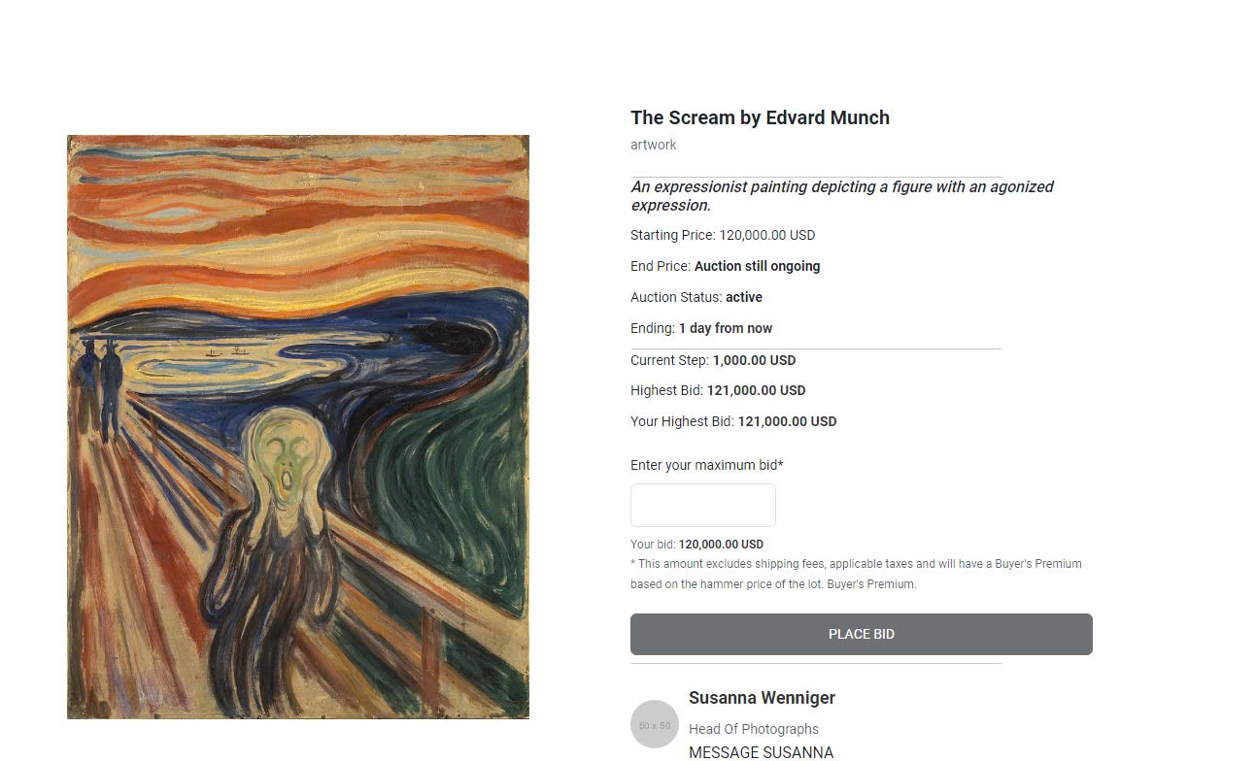

**In next time or n+1 times, if you want to bid, you must to bid higher the highest current bid showed on web**

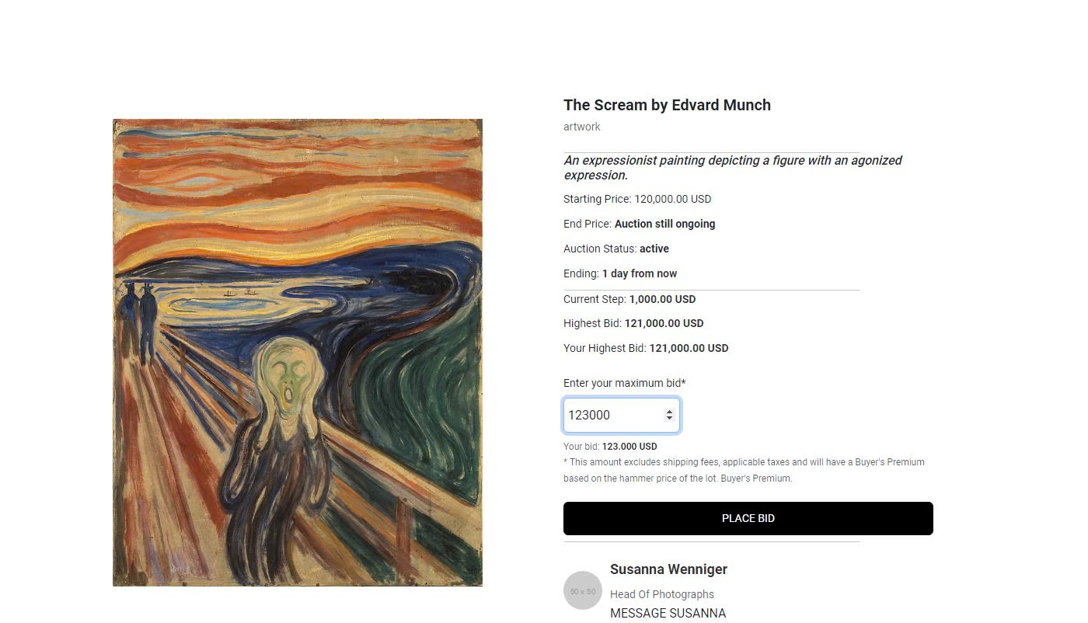

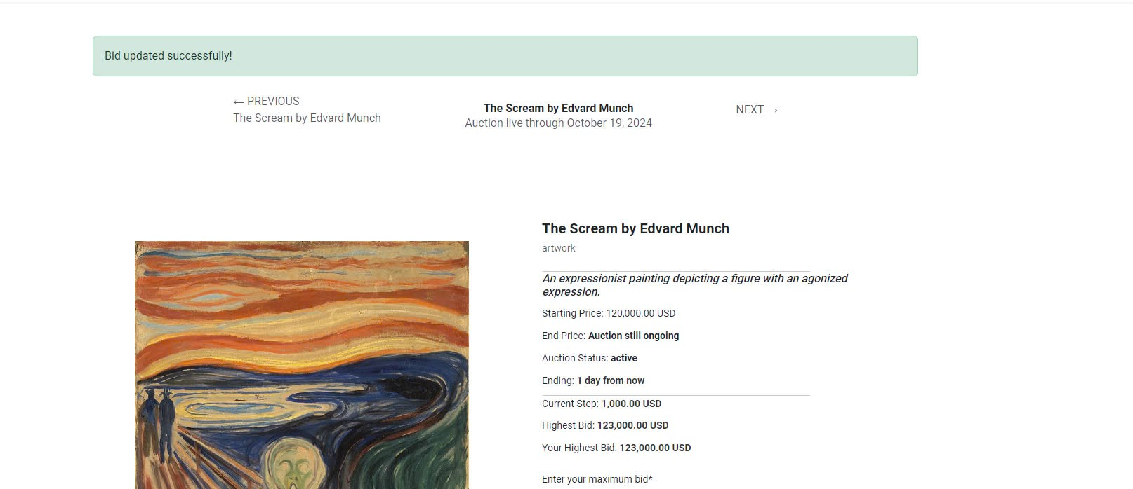

**Successfully**

**e. About Us Page**

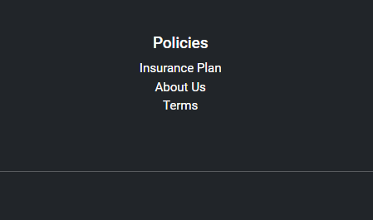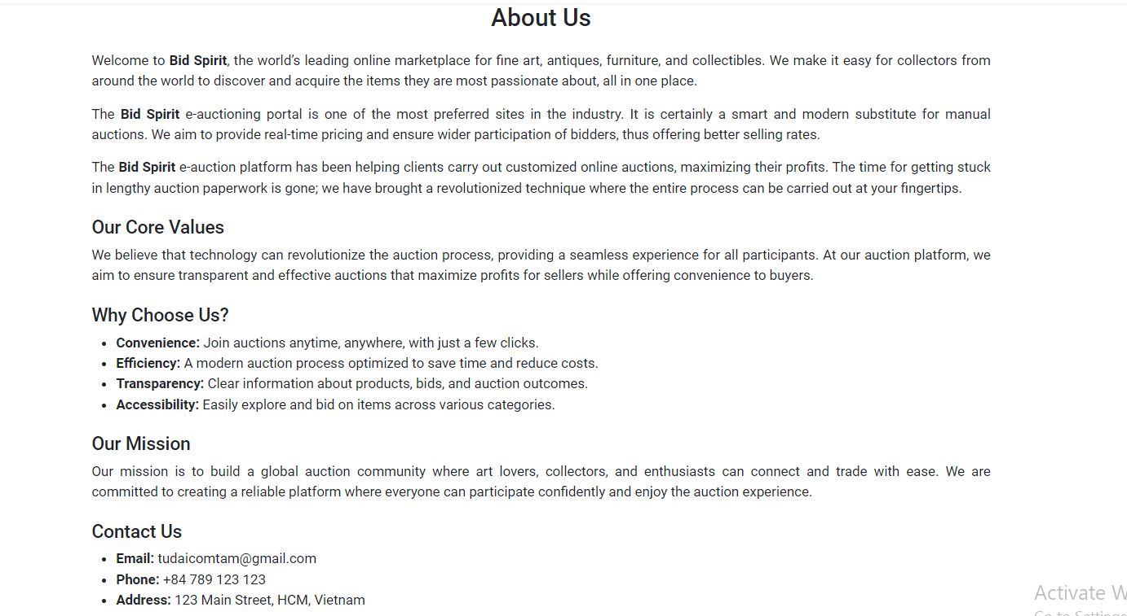

**f. Contact Us Page**

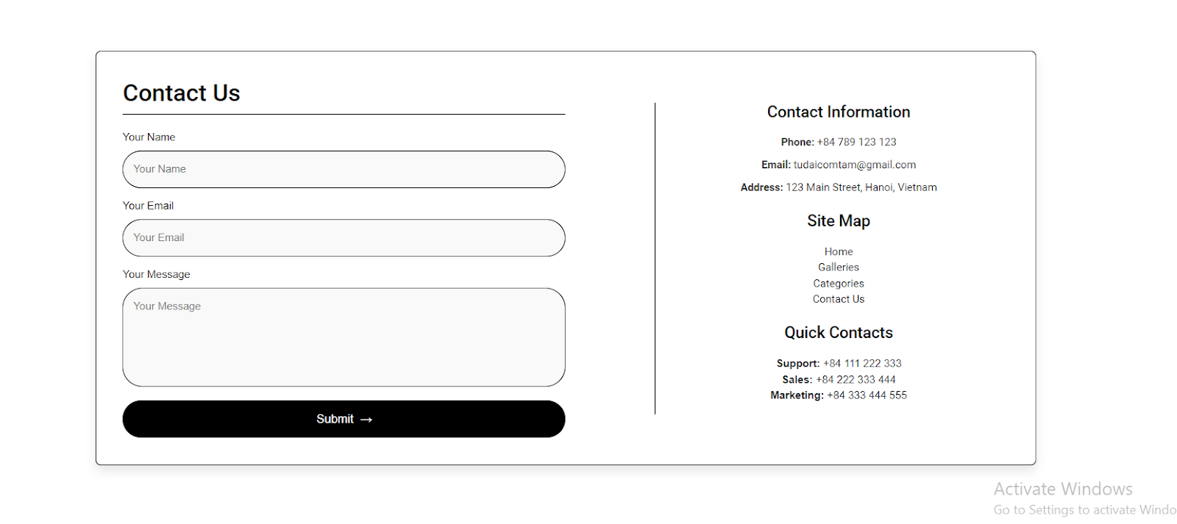

1. **Database**
2. ER Diagram

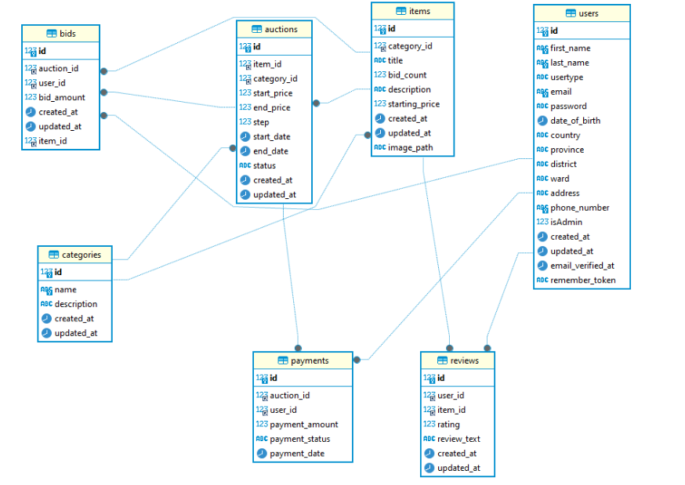

1. Detail of Tables

auctions

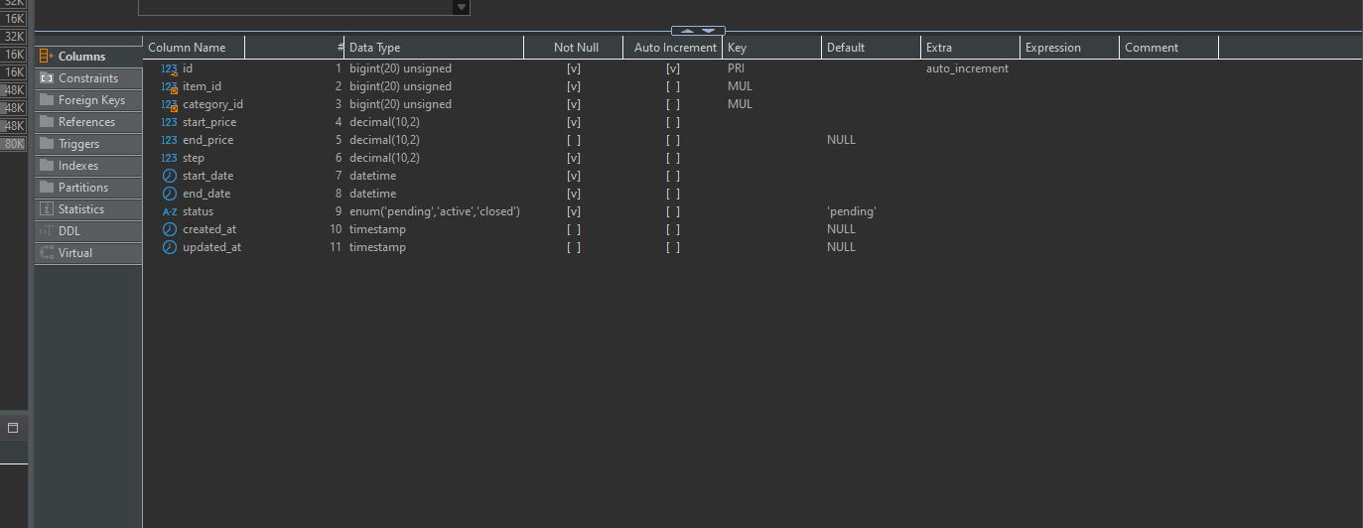

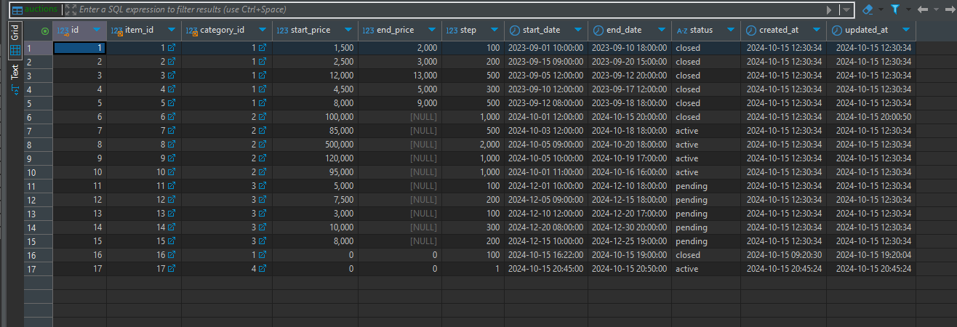

bids

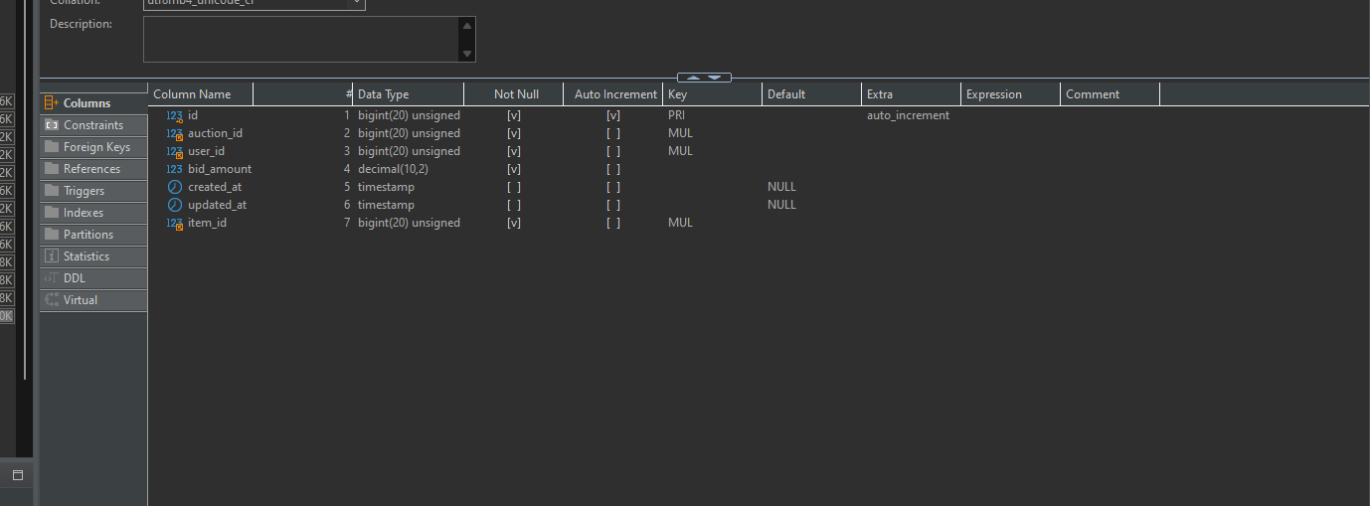

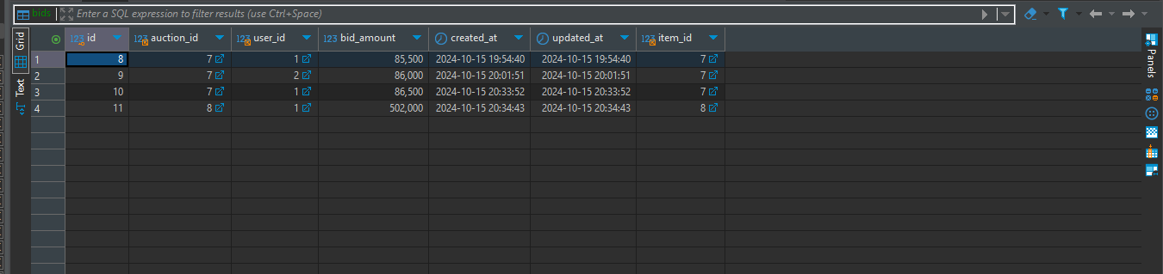

categories:

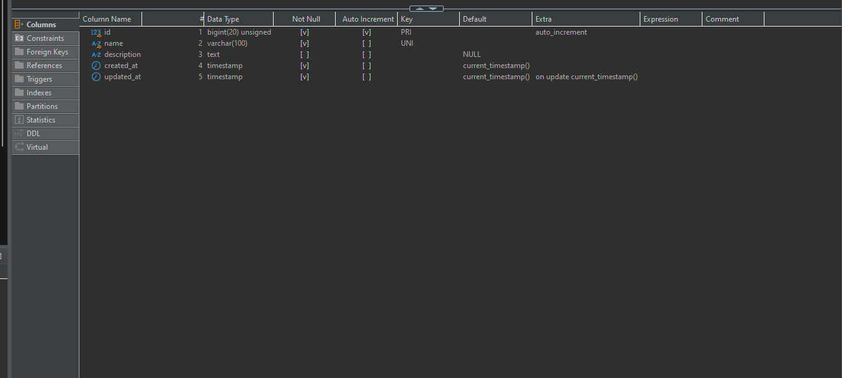

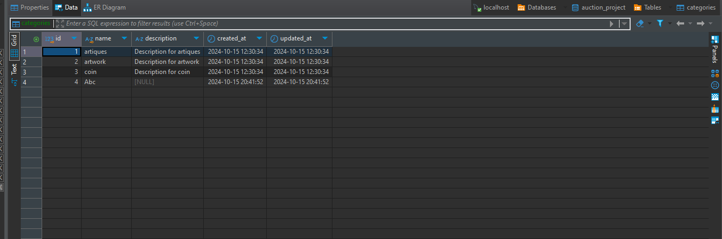

items



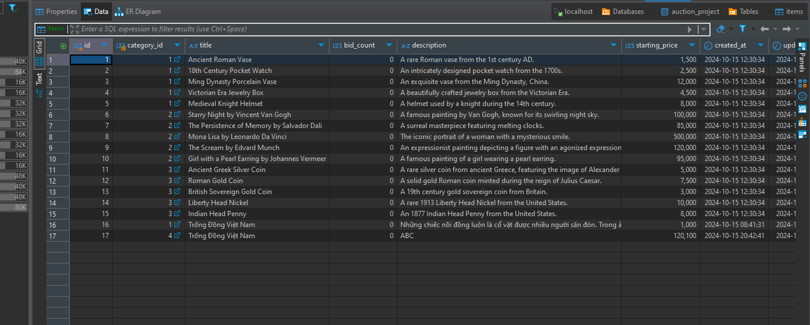

review

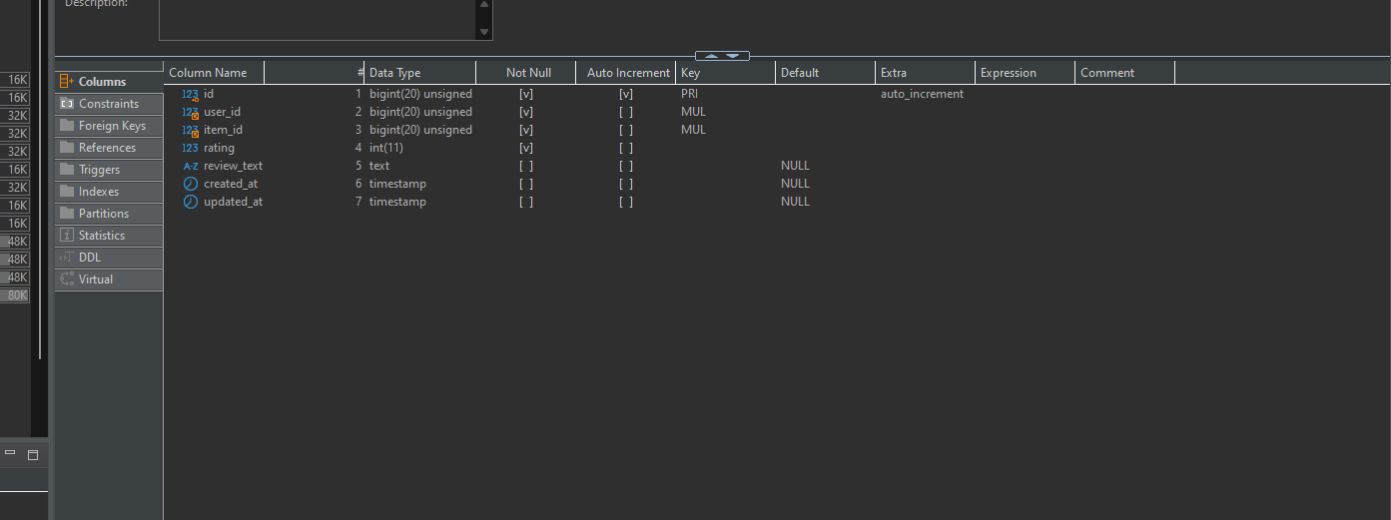

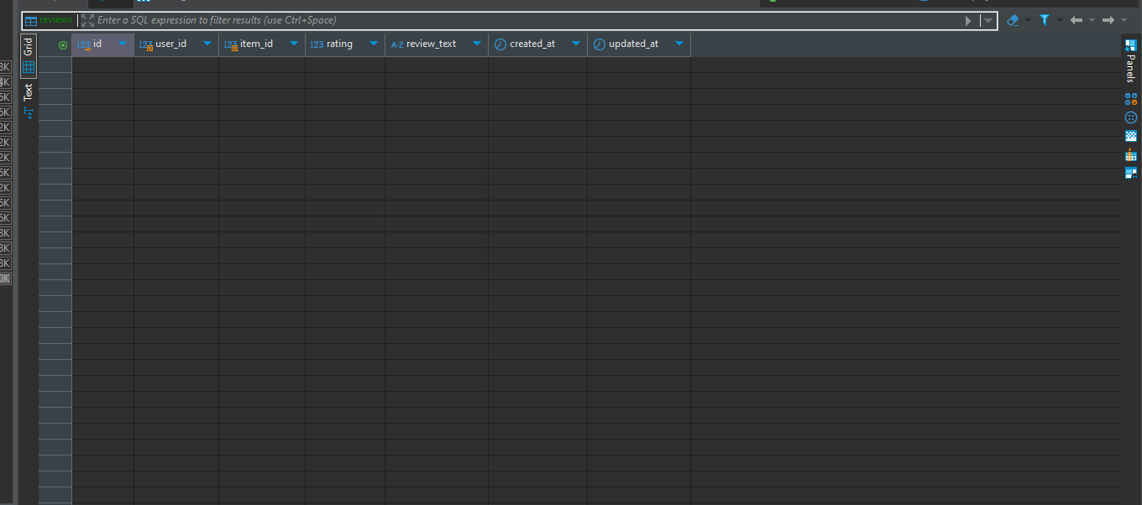

users

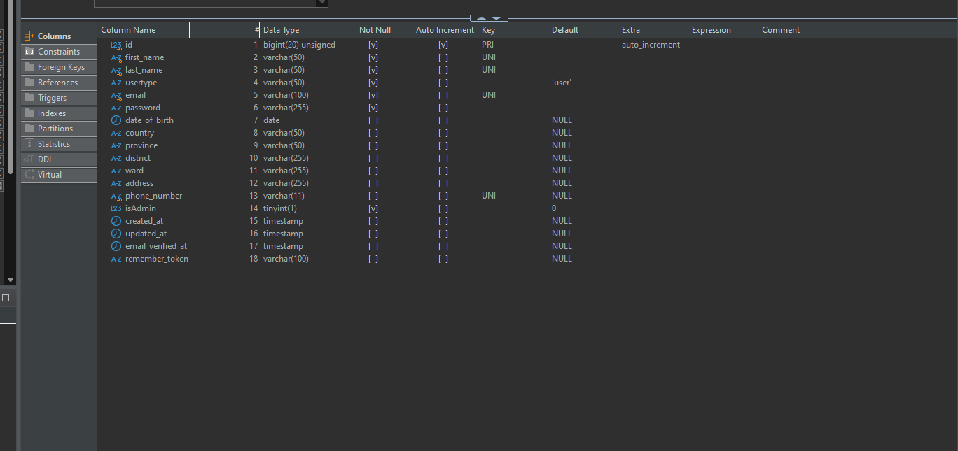



**Tips for Writing Documentation:**

**Use Clear Language**:

Write in a clear and concise manner.

Avoid jargon that might not be familiar to your target audience.

**Include Visuals:**

Use diagrams, charts, and screenshots to illustrate concepts.

Visuals aid understanding and make the documentation more engaging.

**Collaborate:**

If it's a team project, collaborate on documentation to ensure a comprehensive and well-rounded

perspective.

**Follow a Style Guide:**

Adopt a consistent writing style and format throughout the documentation.

**CONTRIBUTIONS**

|  |  |  |
| --- | --- | --- |
| **No.** | **Team Member Name** | **Contributions** |
| **1** | **THIEN THANH NGUYEN** | - User interface (UI/UX) design and user experience. |
|  | - Building template | - Build dynamic page, static page, bootstrap design |
|  | - Building idea for design | - Create idea templates, collect ideas and participate in debugging if any |
| **2** | **KHANH NGUYEN** | - User interface (UI/UX) design and user experience. |
|  | - Building template | -Build dynamic page, static page, bootstrap design |
|  | - Write detailed documentation for each data | -Find the right data to insert into DB |
| **3** | **KHOA TRAN MINH** | - Database construction, data schema design and auction logics. |
|  | - Coding for auction button and web management module. | -Handles logic of buttons and displays. Sets, gets, maps data from database to model |
|  | - Contribution to the automated testing process. | -Embed VN Pay into website  - Development of search and data sorting features. |
| 4 | **XUAN THINH TU** | - Admin page management and design |
|  | - Participation in testing and bug fixing. | - Test the auctions and check for errors if any |
|  | -Create function for admin | -Manage, design CRUD for website users and track user activities |